Summary of Converter Transformer Oil Conservator and Dehydrating Breather

Muhammad Shamaas

The XIAN XD Converter Transformer ZZDFPZ-400400/500-660(330) adopts OFAF cooling method. The barrel type oil tank is filled with Petro China KI50X transformer oil. In order to allow the expansion and contraction of transformer oil during temperature changes, the XD China ZX5461.00534 type Oil Conservator is installed. The Transformer breathes air in and out though the MESSKO MTraB DA200D-T Dehydrating Breather.

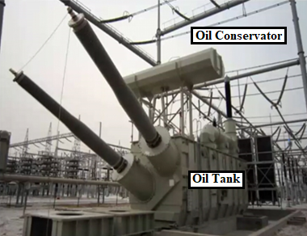

Converter Transformer

1. Transformer Breathing

Converter Transformer Oil Tank is an air tight container completely filled with insulating oil. The atmospheric temperature is never constant and oil temperature varies with the loading of transformer. According to themodynamics law, oil expands at high temperature and contracts at low temperature. Hence an outlet is required to requied to adjust the expansion and contraction of Transformer Oil. Some expansion space is provided in the Oil Conservator placed above the Main Oil Tank. The Oil Conservator can exchange air with the atmosphere through the Dehydrating Breather and connection tube.

The Transformer inhales and exhales air during operation through silica gel breathers. When the oil temperature drops, atmospheric air enters the Oil Conservator through the breather to fill the empty space. First, a steel wire mesh and dust cap filter dust from the air. The filtered air flows through the desiccant chamber and is dehydrated. The dehydrated air rises further via the pipe in the Oil Conservator. When the Transformer Oil heats up and expands, air is pushed out through the Breather.

1. Maintenance of Oil Conservator and Dehydrating Breather

The Maintenance of the Oil Conservator entails the following:

1. Inspection of Oil Gauges: The upper and lower level limits must be checked according to the oil level curve nameplate. The true oil level must be consistent with the oil level indicator and the scale and valves must not be rusty. The oil temperature and pressure must be checked during normal breathing.
2. Inspection of Rubber Bag: If the oil color is abnormal, the Oil Conservator rubber bag must be cleaned, and the oil must be replaced. The seal of the rubber bag must be checked for aging or cracks. Gas pressure test must be conducted for the rubber bag at 0.02-0.03 MPa for 12 hours in a pool to check for leakage of gas or bubbling. There should be no damage during rubber bag inflation inspection. If the rubber bag is damaged, it must be replaced. During installation, blockage of connection pipe and joints must be avoided. Then, the rubber bag must be hanged on the hook and the outlet must be connected. The rubber bag nozzle must be sealed tightly to prevent oil entry.
3. Inspection of appearance: The safety airways, connection pipe, sealing gasket and end cap must be checked for firm installation. Also, the dirt collector must be checked for oil stains.

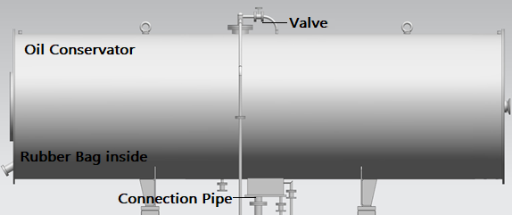

Oil Conservator

The Maintenance of the Dehydrating Breather entails the following:

1. Inspection of Desiccant: The silica gel in the dehydrating breather must be checked for discoloration, insufficient quantity and moisture. If the blue color changes to 2/3 or more red, the silica gel must be replaced.
2. Inspection of Appearance: The breather tube, filter, dust cap, flange and oil seal cup must be checked for cracks, damage, dirt, blockage, oil leakage or looseness. The oil level of the oil seal cup should be appropriate. Bubbling of oil in the oil cup must occur during breathing. If abnormal breathing is found, sudden release of pressure should be avoided.
3. Inspection of Sensors and Control Electronics: Status indicator LEDs and an ERROR relay are provided for indicating Power Voltage Failure (Reference voltage is 230V AC/ 50 Hz), Heater Failure, Desiccant monitoring sensor Failure, Temperature sensor Failure and Device error.

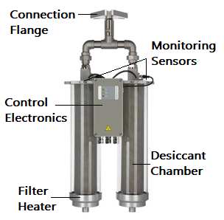

DA200D-T Dehydrating Breather